SQL ASSIGNMENT-4

Create table dept_msu(

Dept_id number primary key,

Dept_name varchar2(50) not null,

Manager_id number,

Location_id number

);

Create table emp(

Emp_id number,

Last_name varchar2(50) not null,

Email varchar2(50) unique,

Salary number check (salary>10000),

Department_id number references dept77(dept_id)

);

2)

1.

Create table emp1(

Emp_id number(7),

Last_name varchar2(50),

first_name varchar2(25),

Salary number,

Department_id number

);

alter table emp1 add constraint my_emp1_id_pk primary key(Emp_id);

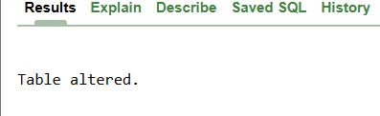

2.

alter table emp1 modify last_name varchar2(50) not null;

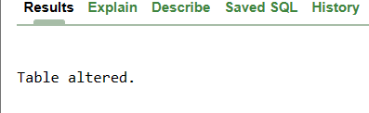

3.

alter table emp1 add constraint f_name unique(first_name);



4.

alter table emp1 add constraint emp1_Salary check (Salary>20000);



5.

6.

alter table emp1 drop constraint my_emp1_id_pk;

